**Assignment 1**

**Shashwat Tripathi**

**D20A 64**

**1. Among Windows and Linux which one provides security?**

Both **Windows** and **Linux** have distinct approaches to security, and the security they provide depends on various factors, such as use case, system configuration, and user behavior.

* **Linux** is often considered more secure than Windows due to its **open-source nature**. This means the Linux community can constantly review the source code, identify vulnerabilities, and patch them quickly. The permission-based model in Linux is strict, with users given limited access to core system files, reducing the risk of accidental or malicious tampering. Additionally, Linux users typically need administrative (root) privileges to install software or change configurations, which adds an extra layer of security. Most malware is targeted at Windows, reducing the risk of attacks on Linux systems.
* **Windows**, while more vulnerable to malware due to its wide user base, has significantly improved its security posture in recent years with features like **BitLocker (full-disk encryption)**, **Windows Defender** (built-in anti-malware and antivirus), **Secure Boot**, and advanced **Windows Firewall** configurations. However, due to its popularity and the fact that many organizations use Windows in enterprise environments, it remains a prime target for malware, ransomware, and phishing attacks.

In conclusion, **Linux is generally perceived as more secure** due to its robust permission system and lower malware targeting, but **Windows provides strong security** features, especially with proper configuration and enterprise solutions.

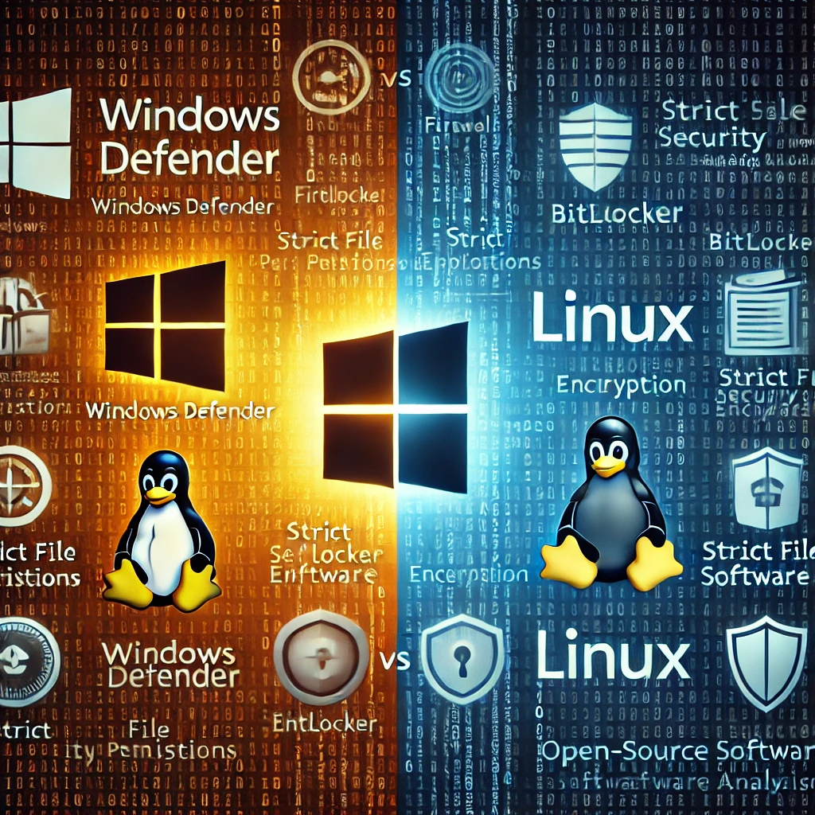

**2. Explain the critical components of cyber security governance.**

**Cyber security governance** refers to the processes and structures an organization puts in place to protect its information assets, systems, and networks. The critical components of cyber security governance include:

1. **Risk Management**:
   * Identifying, assessing, and prioritizing risks related to information security. This involves evaluating the likelihood and potential impact of various threats, such as cyberattacks, data breaches, and system failures, and determining the acceptable levels of risk.
2. **Policies and Procedures**:
   * These are documented guidelines that outline the organization’s approach to securing data, systems, and networks. Policies establish clear roles and responsibilities, define security controls, and guide employees on proper security behavior. For example, access control policies, password policies, and incident response procedures.
3. **Compliance and Legal Requirements**:
   * Organizations must comply with various regulatory and legal frameworks depending on their industry and geographic location. Examples include GDPR (General Data Protection Regulation), HIPAA (Health Insurance Portability and Accountability Act), and PCI DSS (Payment Card Industry Data Security Standard). Governance ensures the organization stays compliant with these regulations.
4. **Incident Response and Recovery Plans**:
   * Organizations must be prepared to respond to security incidents like breaches, malware infections, or insider threats. Incident response plans outline the steps to take in detecting, mitigating, and recovering from an attack, while disaster recovery plans ensure business continuity in the aftermath of a major security event.
5. **Accountability and Roles**:
   * Cyber security governance defines who is responsible for various aspects of security. This includes assigning roles such as a Chief Information Security Officer (CISO), IT security staff, and non-technical employees who handle sensitive information. Clear roles help ensure accountability and efficient response to incidents.
6. **Continuous Monitoring and Auditing**:
   * Regular security audits, vulnerability assessments, and continuous monitoring of networks and systems are critical for identifying potential weaknesses and ensuring that security controls are working effectively. Governance ensures that these practices are integrated into everyday business processes.

**3. Explain the role of CERT, the emergency response team for data security mechanisms.**

**Computer Emergency Response Teams (CERTs)**, also known as Computer Security Incident Response Teams (CSIRTs), play a crucial role in safeguarding organizations and nations from cybersecurity threats. CERTs focus on responding to security incidents, improving security awareness, and coordinating efforts to mitigate cyber threats. The key roles of CERT include:

1. **Incident Detection and Response**:
   * CERTs are the first line of defense when a security breach or cyberattack occurs. They quickly assess the situation, determine the scope of the incident, and coordinate efforts to mitigate the attack. This includes isolating affected systems, applying patches, and ensuring the attack doesn’t spread.
2. **Threat Analysis and Vulnerability Assessment**:
   * CERTs constantly monitor for new threats and vulnerabilities that could impact systems and networks. They analyze cyber threats and develop strategies to protect against them. CERTs also assist in vulnerability assessments, helping organizations identify weaknesses in their systems before attackers can exploit them.
3. **Coordinating Incident Communication**:
   * During a significant incident, CERTs act as central points for communication. They coordinate with different teams within an organization or external bodies like law enforcement, other CERTs, or industry partners to share information about the attack, mitigation strategies, and potential impacts.
4. **Security Awareness and Training**:
   * CERTs often conduct training sessions and awareness campaigns to educate employees and organizations about best security practices. They provide guidelines for securing systems, recognizing phishing attempts, and responding to incidents.
5. **Policy Recommendations**:
   * CERTs may offer guidance on improving security policies and procedures. This includes recommending the adoption of new technologies, security patches, or regulatory compliance measures based on evolving cyber threats.
6. **Post-Incident Analysis**:
   * After an incident, CERTs perform detailed analyses to understand how the attack happened, what vulnerabilities were exploited, and what actions should be taken to prevent future occurrences. This information is shared with affected organizations and across industries to bolster defenses.

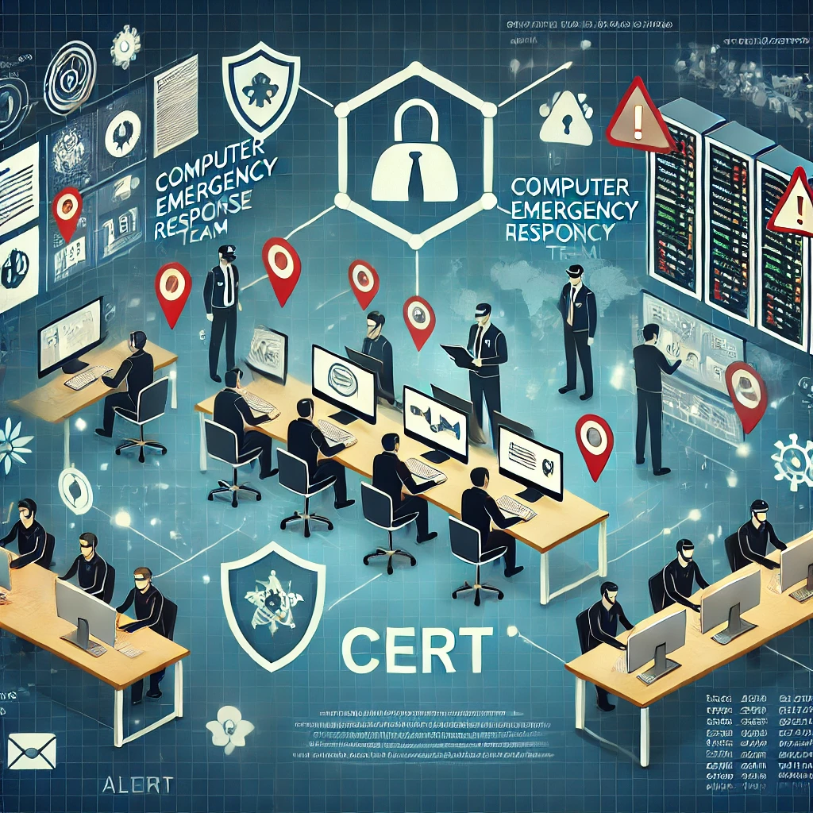

**4. What approach can you take to defend the phishing attempts?**

To defend against **phishing attempts**, a multi-layered approach is essential. Key defense strategies include:

1. **Awareness and Training**:
   * Regularly train employees and users to recognize phishing emails and malicious links. Educate them about common signs of phishing, such as unfamiliar email addresses, misspellings, urgent requests for sensitive information, and suspicious attachments.
2. **Email Filtering and Anti-Phishing Tools**:
   * Deploy advanced email filtering systems that detect and block phishing emails before they reach the user's inbox. These tools often use machine learning algorithms to identify phishing attempts based on email content and metadata.
3. **Multi-Factor Authentication (MFA)**:
   * Enforce **MFA** across accounts, which requires users to provide two or more forms of authentication. Even if phishing attackers obtain a user's password, they won’t be able to access the account without the second factor, such as a text message code or authenticator app token.
4. **Security Awareness Testing (Phishing Simulations)**:
   * Conduct phishing simulations within the organization to test users' awareness and reactions. This helps identify vulnerable employees and provides insights into which areas of security training need improvement.
5. **DNS Filtering**:
   * Use **DNS filtering** to prevent users from visiting known phishing websites. This blocks access to malicious websites even if the user clicks on a phishing link, reducing the risk of credential theft or malware infection.
6. **Incident Response Plans**:
   * Establish and maintain a clear incident response plan to handle phishing attacks. This includes identifying affected systems, isolating them, resetting credentials, and analyzing the impact of the phishing attempt.

**5. Mention the OWASP risk rating methodology.**

The **OWASP risk rating methodology** provides a framework for assessing the severity and impact of security vulnerabilities in web applications. This methodology assigns a risk score to each identified vulnerability based on four factors:

1. **Threat Agent Factors**:
   * Evaluates who the potential attackers are and their capabilities. Considerations include:
     + **Skill level**: How skilled are the attackers?
     + **Motive**: What is the attacker’s intent (financial gain, data theft)?
     + **Opportunity**: How easy is it for the attacker to exploit the vulnerability?
     + **Size**: How large is the group of potential attackers?
2. **Vulnerability Factors**:
   * Assesses the ease of exploitability of the vulnerability:
     + **Ease of discovery**: How easily can the vulnerability be discovered?
     + **Ease of exploit**: How easy is it to exploit the vulnerability once discovered?
     + **Awareness**: How well-known is the vulnerability to the attacker?
     + **Intrusion detection**: How easy is it for defenders to detect the exploitation?
3. **Technical Impact**:
   * Measures the potential damage to the application or system:
     + **Confidentiality**: Will sensitive data be exposed?
     + **Integrity**: Can data be altered by the attacker?
     + **Availability**: Will the application or service be disrupted?
     + **Accountability**: Can the attacker's actions be traced?
4. **Business Impact**:
   * Considers the impact on the organization’s operations:
     + **Financial damage**: How much financial loss could occur?
     + **Reputation**: How would it affect the organization’s reputation?
     + **Non-compliance**: Are there legal or regulatory consequences?
     + **Privacy**: Is sensitive user data at risk?

Each factor is scored, and the combined score determines the overall risk rating, helping organizations prioritize remediation efforts.

**6. Mention the list of challenges for the successful deployment and monitoring the web intrusion detection?**

Deploying and monitoring **web intrusion detection systems (IDS)** effectively presents several challenges:

1. **False Positives and False Negatives**:
   * One of the biggest challenges is reducing the number of **false positives** (benign activity flagged as malicious) and **false negatives** (real threats not detected). Excessive false positives can overwhelm security teams and lead to alert fatigue.
2. **Performance Overhead**:
   * Intrusion detection systems, especially those deployed in real-time, can introduce performance overhead. Monitoring and analyzing large volumes of web traffic can slow down the web application and affect user experience.
3. **Evolving Attack Vectors**:
   * Attack techniques continuously evolve, and web intrusion detection systems need to stay updated to recognize new vulnerabilities and exploits. Regular updates and machine learning models are needed to adapt to changing threats.
4. **Encryption Challenges**:
   * Many modern web applications use **HTTPS** for secure communication. While encryption protects data, it can make it harder for intrusion detection systems to analyze encrypted traffic for malicious content without SSL/TLS interception, which introduces privacy concerns.
5. **Scalability**:
   * As web applications grow, scaling an intrusion detection system to handle increasing traffic and complex architectures (microservices, cloud environments) can be difficult. Large-scale systems require robust architecture and tuning.
6. **Integration with Existing Security Infrastructure**:
   * Successfully integrating an IDS with other security tools like firewalls, SIEM (Security Information and Event Management) systems, and network monitoring tools is a challenge. Misconfigured integrations can lead to delays in incident detection or incomplete data collection.
7. **Human Expertise and Continuous Monitoring**:
   * Effective deployment of web IDS requires skilled security professionals to configure, monitor, and respond to alerts. Continuous monitoring is essential, as attackers often exploit vulnerabilities when security teams are not actively observing.